Unit 6 HW
- Simply Answer Question 25 on pg. 147 from the Statistical Sleuth!
Plot the raw data, and also plot the data after a log transform. After a log transform, do the data satisfy the assumptions better? The data is in ex0525.csv or ex0525.xlsx. Perform this analysis in SAS. [Depending on where you find the data set, you may see the value <<12. Note that <<12 = 12.]
Regardless of whether the assumptions of the original data or log transformed data are met, please include a complete analysis on the log transformed data.
- State the Problem.
- Address the assumptions. Comment on each assumption. (Use the visual test, as the Brown-Forsythe test will be overpowered due to the large sample size. This simply means that it is able to detect very small effect sizes—here, differences in standard deviations—which may not be big enough to practically affect the test.) Comment on your thoughts of the assumptions, but, in the end, assume there is not enough visual evidence to suggest the standard deviations of the log transformed data are different.
- Conduct the Test. (An example is in the UNIT 6 PowerPoint.)
- Write a conclusion. (An example is in the UNIT 6 PowerPoint.)
- State the Scope. (Can we generalize to the entire population or just the sample that was taken? Is there a causal relationship present?)
ADDITIONAL THINGS TO INCLUDE (for the logged data):
- Please also identify R²
- Also specify the mean square error and how many degrees of freedom were used to estimate it.
- Provide the code to perform the ANOVA in R and a screen shot of the output.

Looking to the future! This is not an additional problem. Just FYI: The next step will be to look at these pairwise if we reject the H_{o} to discover WHICH pairs have evidence of different means / medians.

- 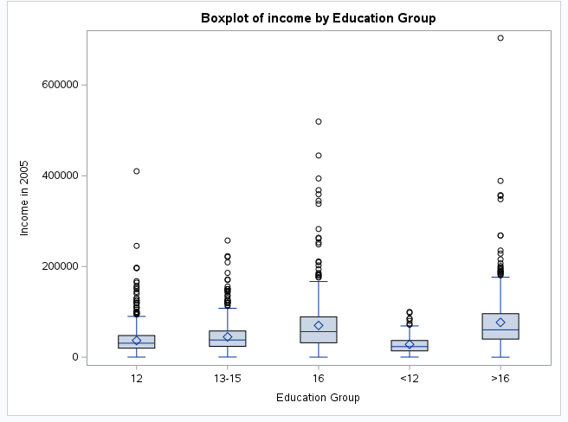
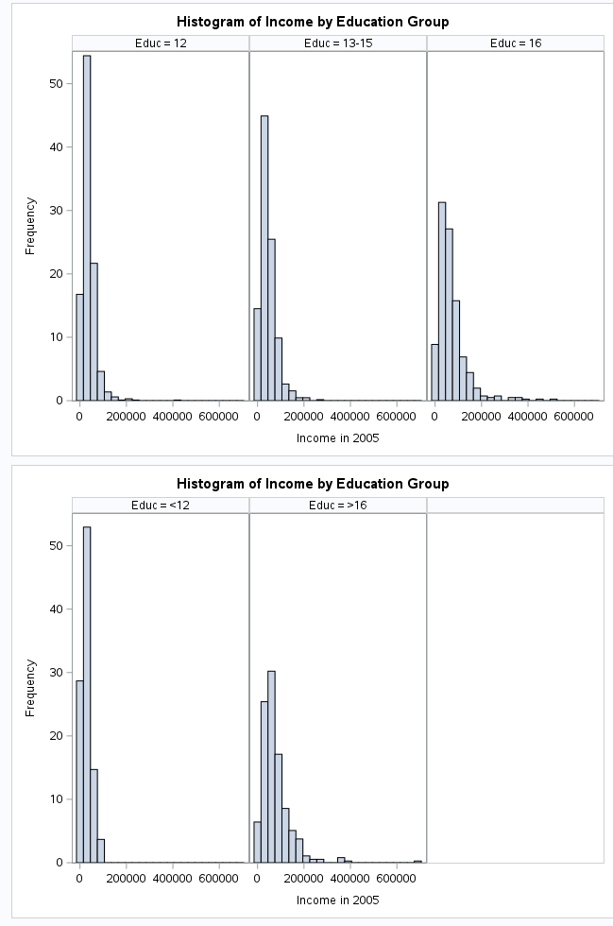
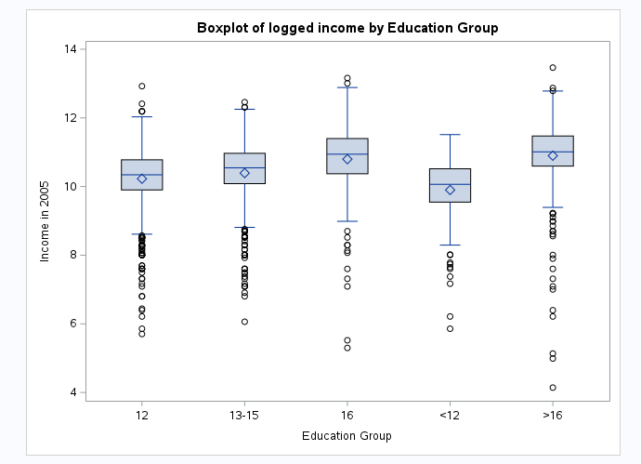
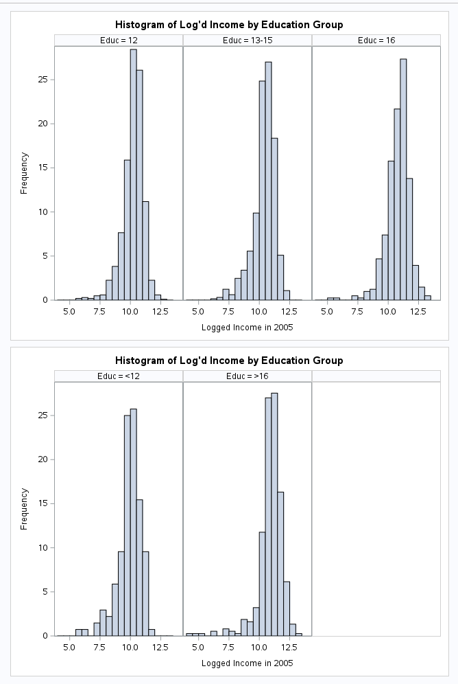
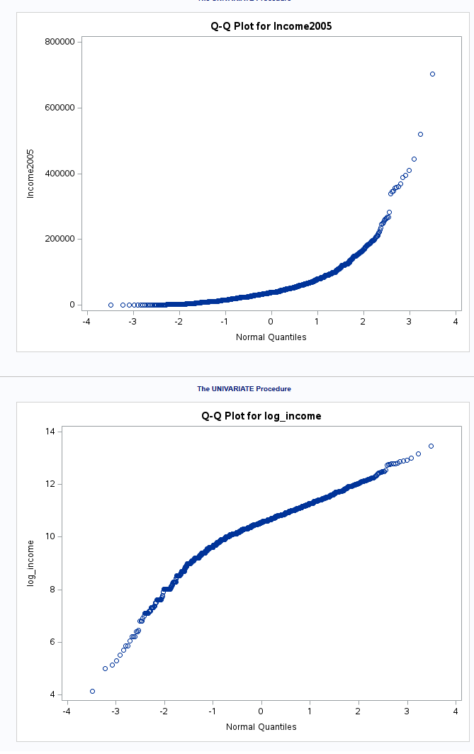
Problem: We need to determine if the evidence suggests that at least one of the 5 groups are different from the rest through an analysis of variance test (ANOVA).
Assumption: After plotting the data through a box plot and a histogram, its visually clear that the data is skewed to the right and significant amount of outliers. Since the data do not have a normal distribution, it needs to be logarithmically transformed and that molds the distribution around the median and normalizes it. The data QQ Plot of a before and after shows the transformed data follows more of a normal distribution. The data does not provide enough visual evidence to suggest that the variance has any difference. We will assume that survey was sampled properly and the subjects are independent from each other.
Test:
H0: 𝝁_{>12} = 𝝁₁₂ = 𝝁₁₃₋₁₅ = 𝝁₁₆ = 𝝁_{>16}
Ha:𝝁_{>12} 𝝁₁₂ 𝝁₁₃₋₁₅ 𝝁₁₆ 𝝁_{>16}
SAS Code:
proc glm data = work.import;
class Educ;
model log_income = Educ;
run;
l

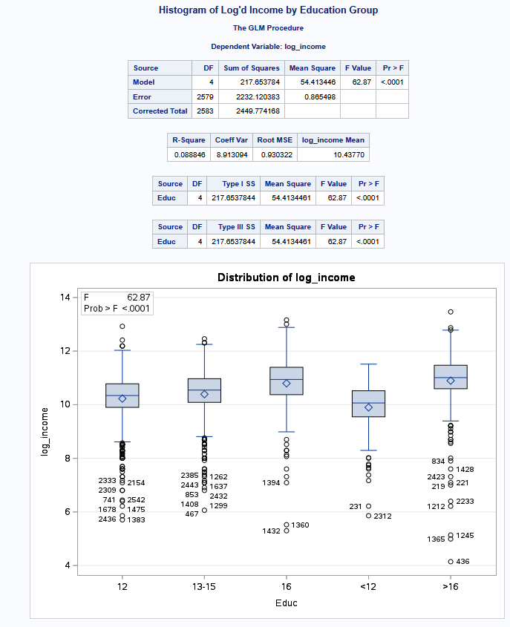
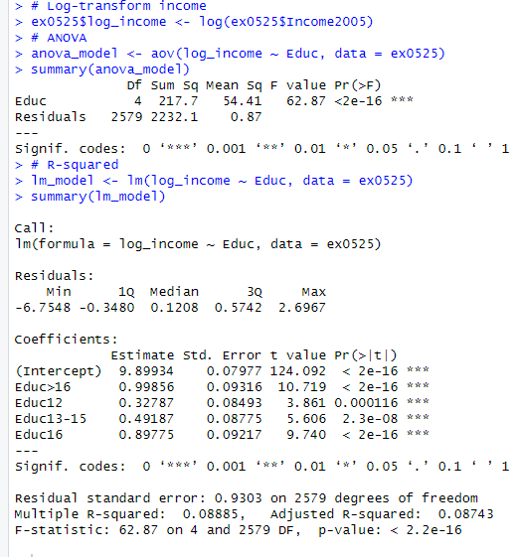

Conclusion:
Initially the raw data did not visually indicate a normal distribution, so we opted to use logarithm to create a normal distribution. After the transformation, there was not enough visual evidence to suggest that the data was not normal nor the unequal variances and we proceeded. Due to having multiple groups, the most appropriate test would be an Analysis of Variance (ANOVA) to determine if any of the income groups differ from each other. After running an ANOVA Test on the log-transformed data, our P-Value for the test is below .0001. The degrees of freedom in between each group was 4 and means square error was 54.4, which is significant when compared to the mean square for the whole sample size which was .8. There was significant difference between the MSEs of the whole sample size and each income group. Due to that, we calculated a F Statistic of 62.87, which is an exceptionally large value, giving us overwhelming evidence that suggests that at least one of the groups of Income are different from the rest.
Scope:
The data was collected through the census of people that were born through small range of years (1957 - 1964) and in America. This prevents us from generalizing outside of that population. The survey did not conduct any random sampling, leaving us unable to infer a causal relationship. The study does indicate some level of relationship and suggest for further study.

2. Use an extra sum of squares F-test (BYOA: Build Your Own ANOVA!) to use all the data (to increase the degrees of freedom and thus the power of the test!) to compare only the bachelor’s degree group (16) income to the more than bachelor’s degree group (>16) income. Show your final ANOVA table and your 6-step complete analysis. You will need to assume that the standard deviations of the log-transformed data are again equal to proceed here. A two-sample t-test between these two groups (assuming equal standard deviations on logged data) yields a p-value of .1648 (try it!), but it only uses 778 degrees of freedom (from a pooled t-test). Make note again of how many degrees of freedom were used to estimate the pooled standard deviation in your extra sum of squares test. You may use SAS or R.

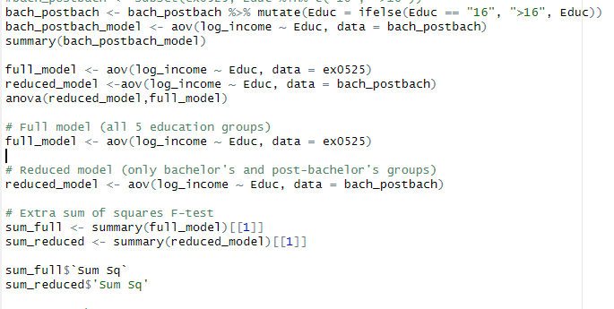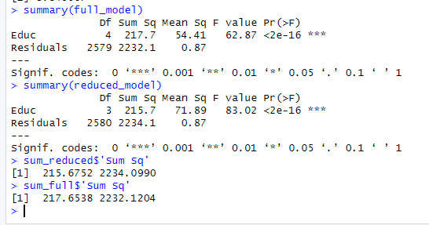

 | DF | SSR | MS | F | Pvalue
Extra | 1 | 2 | 2 | 2.31 | .128666
Reduced | 2579 | 2232.1204 | .865498
Full | 2580 | 2234.0990 | .865929
H0: 𝝁_{>12} = 𝝁₁₂ = 𝝁₁₃₋₁₅ = 𝝁_{16=>16}
Ha:𝝁_{>12} 𝝁₁₂ 𝝁₁₃₋₁₅ 𝝁₁₆ 𝝁_{>16}
Critical Value: 3.84 (.05 Significance Level)
_{F:Value 2.31}
PValue: .12866 (Fail to Reject Null Hypothesis)
_{Conclusion:}
In order to compare the education groups 16 (Bachelors) and >16(Post-Bachelor), we proceeded to combine the two groups and assume them as the same population group.Since the raw data does not meet the assumptions, especially on normality, we used the logarithm of the income to create a normal distribution. If the Null hypothesis was not rejected, we did not have enough evidence to show that means of bachelors and post bachelor graduates are different. We proceed to run with a Extra Sum of Squares ANOVA test to increase the degrees of freedom and power of the analysis compared to the T-Test. We had reached a Fstatistic of 2.31 giving our sample a P-value of .12866, not statistically significant enough for us to reject the the assumption that all the educations groups are the same.

3. Now, suppose that you cannot assume the standard deviations are the same (for both the original or log transformed data). Conduct another complete analysis of the question in Chapter 5, problem 25 in Statistical Sleuth. Answer the question, “How strong is the evidence that at least one of the five population distributions (corresponding to the different years of education) is different from the others?” This question should be answered in at least 1 or 2 sentences after providing a complete analysis without the assumption of equal standard deviations for the logged data (or for the original data). Perform the test in SAS or R.

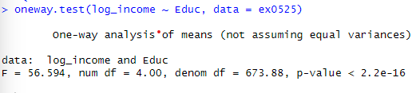
H0: 𝝁_{>12} = 𝝁₁₂ = 𝝁₁₃₋₁₅ = 𝝁₁₆ = 𝝁_{>16}
Ha:𝝁_{>12} 𝝁₁₂ 𝝁₁₃₋₁₅ 𝝁₁₆ 𝝁_{>16}
_{Critical Value: 2.385151}
_{F-Value: 56.594}
PValue: <.0001 (Reject the Null Hypothesis)
_{Conclusion:}
Assuming that we are unable to determine that the variances are the same between each group, we chose to run the Welch’s ANOVA test. We chose the Welch’s ANOVA test, because we transformed the income data using its logarithm and that normalizes the data and meets the assumption for the Welch’s Test, shown by the QQ Plot of before and after (Question 1). The test calculated the F Statistic to an astounding 56.594, which is overwhelmingly significant and well above our Critical Value of 2.38. The PValue for the F Statistic is extremely low (<.0001), heavily suggesting that we should reject the notion that all the education groups have the same income. This is despite the fact that we are unable to assume the groups have the same variance between each other. The data suggests there is very strong evidence that at least one of the groups are different from each other, regardless of how varying their standard deviations are.

